Southern Campaign Escape Room Directions

Step 1: GOAL- Explain to students that a vital message MUST be delivered to the correct person at the correct location before time runs out or risk the Americans losing the Revolutionary War. They MUST figure out how to unlock the message in time by figuring out the clues and unlocking the next activity.

Step 2: Break the students into three groups

Step 3: Hide an index card (with the phrase: This task will be easy if you just use Common Sense) in plain sight somewhere in the room (I chose to staple it next to a picture of George Washington on my classroom wall).

Step 4: The first set of clues to decipher that will open the Word Lock was hidden inside a copy of Thomas Paine’s, Common Sense.

Activity 1: Each group will be assigned a pension record to evaluate
Pension Record Escape Room Clues.docx
Pension Records
Click on the link or copy in browser to direct you to the pensioner’s record.
Thomas Young- http://revwarapps.org/s10309.pdf
Andrew Ferguson- http://revwarapps.org/s32243.pdf
William Meade- http://revwarapps.org/s19394.pdf
Silas P. Wooten- http://revwarapps.org/s40730.pdf
Step 5: Use code deciphered in Activity 1 to unlock Activity 2 in first lock box
Step 6: Activity 2- Follow the directions using the letters and puzzle pieces inside the box to find the clues and code to open lock box #2.
Inside of lock box #2 is a set of UV flashlights and three ziplock bags with puzzle pieces and a letter from the Southern Campaign (primary resource) for each of the groups. The students need to read their groups letter and then put together their puzzle, (answer the question listed below in the directions). One of the puzzles will have the correct symbol (answer written in UV pen, the other three will be distractors with penalties.

Teacher Info Activity 3

Directions: Read the primary source documents (letters) linked below
What is the common historical thread of the letters?
Put your group’s puzzle together to see if you have the correct answer.

Click on the links below to access the Letters from the Southern Campaign
http://www.battleofcowpens.com/battle-of-cowpens-letters/charles-cornwallis-banastre-tarleton-18-dec-1780/
http://www.battleofcowpens.com/digital-documents/daniel-morgans-letters-nathanael-greene/
http://www.loc.gov/teachers/classroommaterials/presentationsandactivities/presentations/timeline/amrev/south/greene.html

Step 7: The code from Activity 2 will open the lock box containing activity 3

Step 8: Activity 3- (Use timeline link below) Print cards and cut them apart. Distribute one set of cards to each group. Students will put them in the order in which the historical events happened. They will have to use inquiry to find the dates. (Optional: time students to see how quickly they can put them in the correct order). If the order is correct each group will use the UV flashlight to reveal the clue to figure out the number they must contribute to unlock the last box. Inside last lock box is the message. (Teachers: Make sure you print final message and place in 3rd locked box)
Final Message.docx
Southern Campaign Timeline.docx

Step 9: But wait… you are trapped in the room… to unlock the door lock you MUST figure out the code by identifying to whom and where the message is to be delivered.
Display these clues on the projector screen after all 3 locked boxes have been opened.

Where: You MUST take the message from the colony established in 1670, to somewhere important to the Revolution in the colony established in 1607. (Hint you MUST know the rank in order of date)

Who: Deliver it to the 1st
Answer to last clues:
SC est. 1670 was the 11th colony
Virginia est. 1607 was the 1st (somewhere important is Yorktown) Deliver to George Washington the 1st president
Get the message to George Washington in Yorktown, Virginia
To unlock the door use the code 111
Step 10: Unlock the door and get the message delivered.
Supplies I used (Click on the pictures)
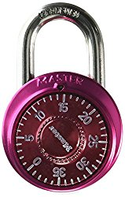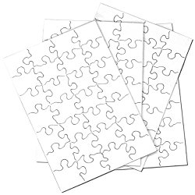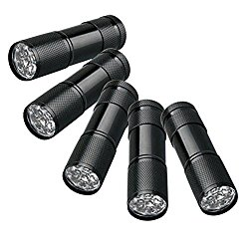

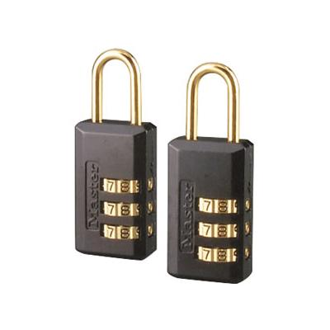

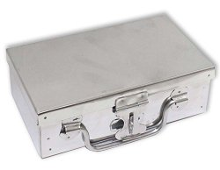(3 boxes, any kind as long as you can find a way to lock them)

